LAB 3
DATE: 8-08-23

WAN NETWORK

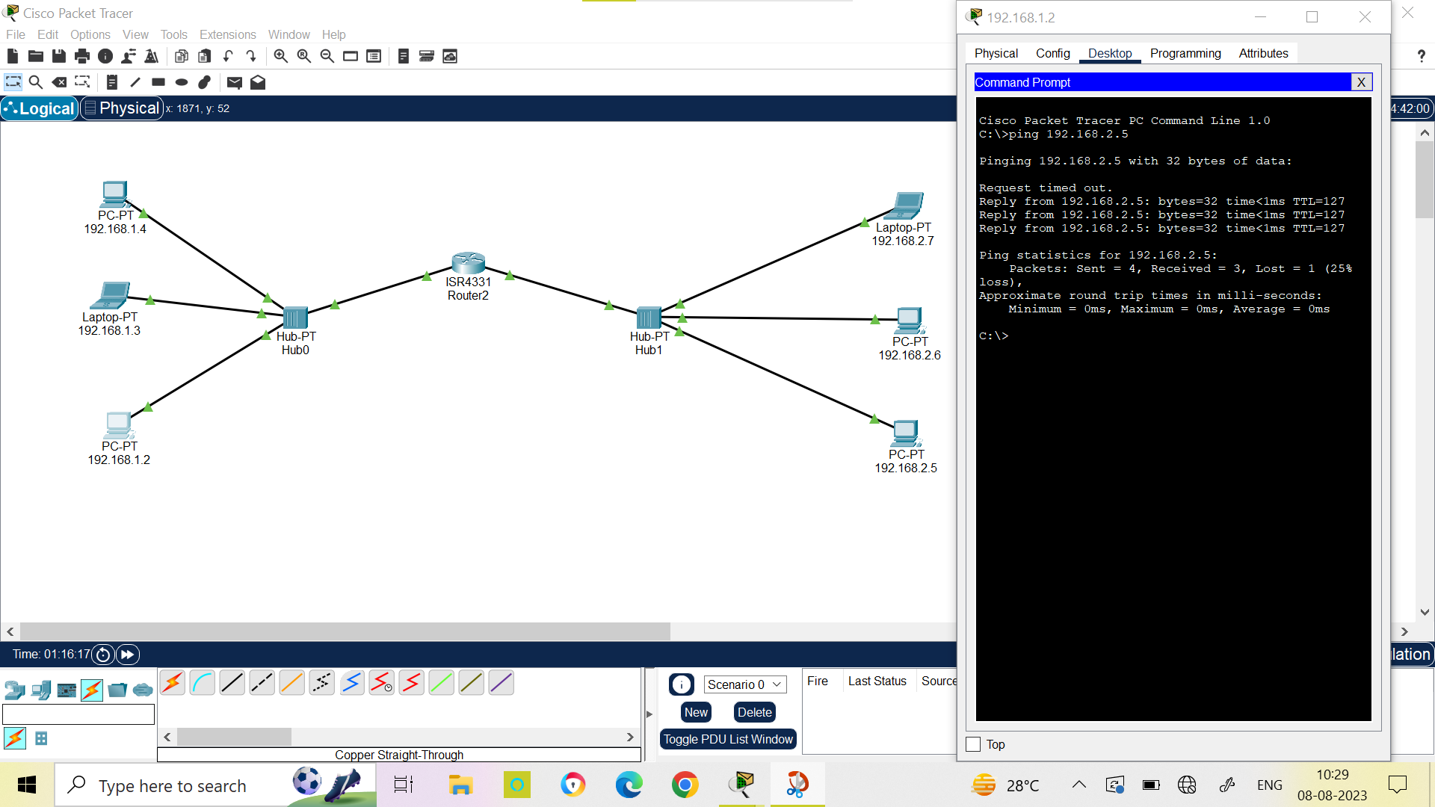

COMPUTER NETWORKS LAB

NAME: SHEEFA NAAZ
ROLL NO. : 2128085
SECTION: CSSE 2
SESSION: AUTUMN 2023

